Subtraction 1°
🌟Subtraction – Practice exercises
Exercise 1
 | T | O
 | $$5$$ | $$8$$
$$-$$ | $$3$$ | $$5$$
- If it is easier for you, you can just represent the number. Remember, you only need to represent the number on the top because you are going to subtract.
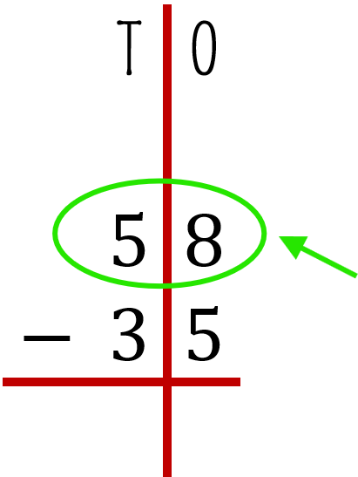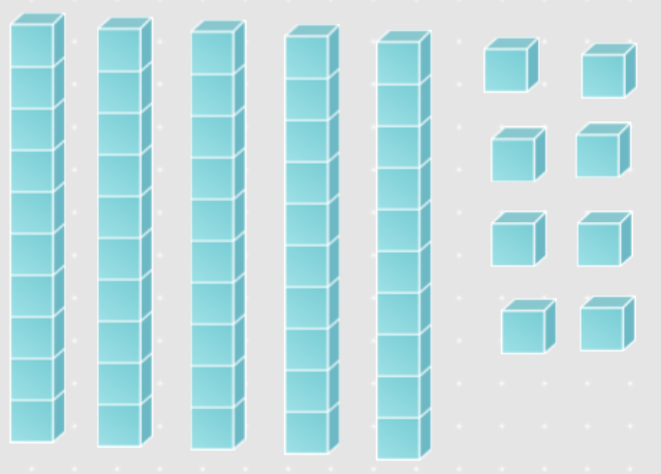
- Now start with the ones. On top you have 8, which means you need to solve 8 minus 5. Do you have enough ones to take away 5?
Yes! Look:  👁️ 👁️ | 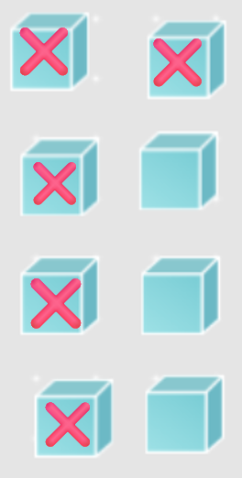
So… 8 – 5 = 3 | 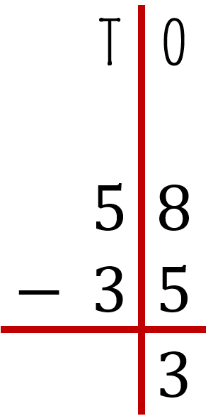
- Continue with tens. On top you have 5, which means you need to solve 5 minus 3. Do you have enough tens to take away 3?
Yes! Look:  👁️ 👁️ | 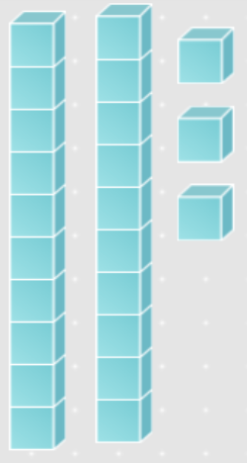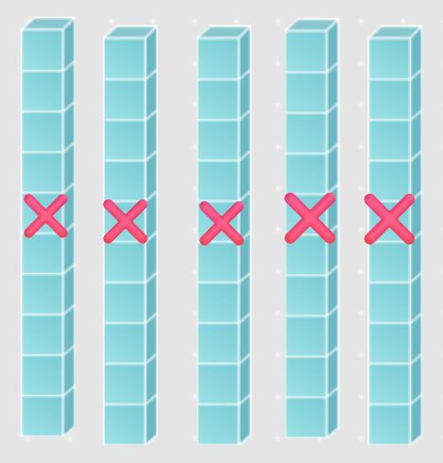
So… 5 – 3 = 2 | 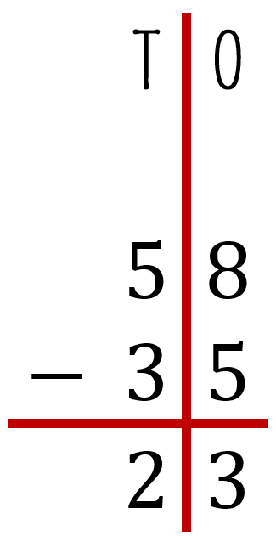

- Finally, the answer is 23:
 | T | O | ➡️ 
 | $$5$$ | $$8$$
$$-$$ | $$3$$ | $$5$$
 | $$2$$ | $$3$$

Exercise 2
 | T | O
 | $$9$$ | $$3$$
$$-$$ | $$9$$ | $$1$$
- Represent the number. Remember, you only need to represent the number on the top because you are going to subtract.
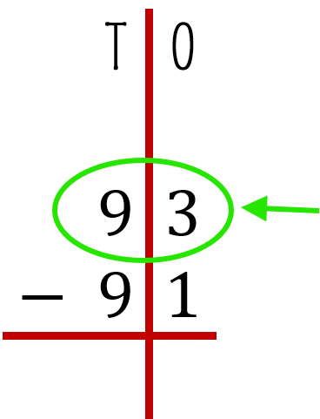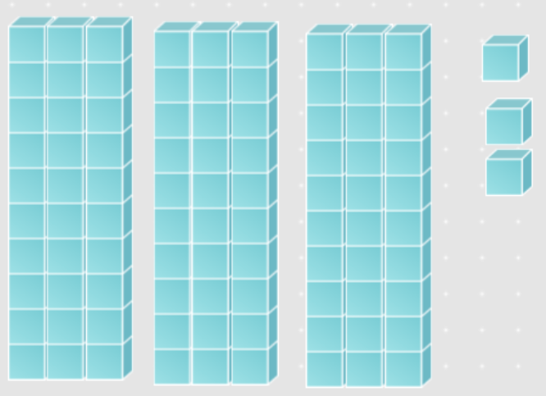
- Now start with the ones. On top you have 3, which means you need to solve 3 minus 1. Do you have enough ones to take away 1?
Yes! Look:  👁️ 👁️ | 
So… 3 – 1 = 2 | 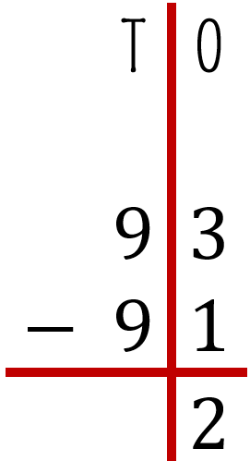
- Continue with tens. On top you have 9, which means you need to solve 9 minus 9. Do you have enough tens to take away 9?
Yes! Look:  👁️ 👁️ | 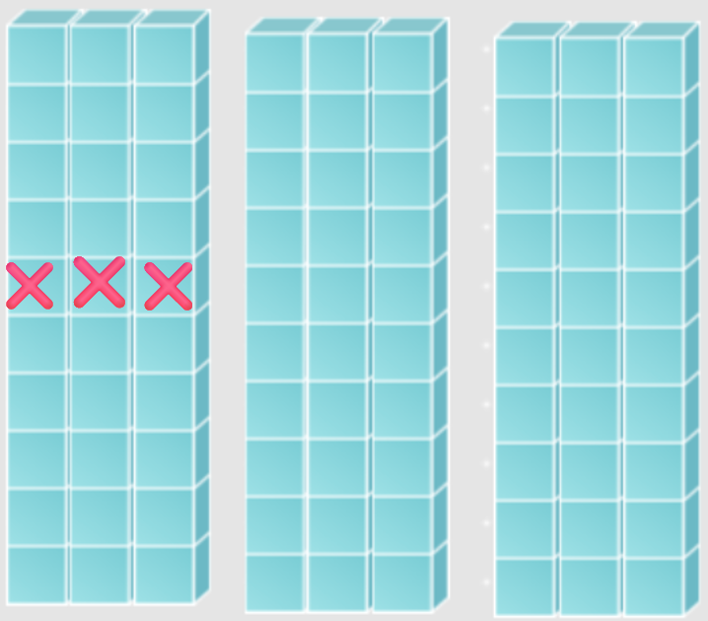
So… 9 – 9 = 0 | 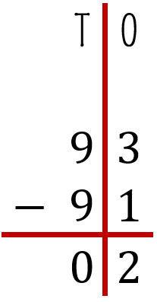

- Finally, the answer is 2:

 | T | O | ➡️ 
 | $$9$$ | $$3$$
$$-$$ | $$9$$ | $$1$$
 | $$0$$ | $$2$$

Exercise 3
 | T | O
 | $$4$$ | $$3$$
$$-$$ | $$2$$ | $$7$$
- Represent the number. Remember, you only need to represent the number on the top because you are going to subtract.
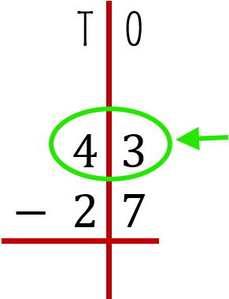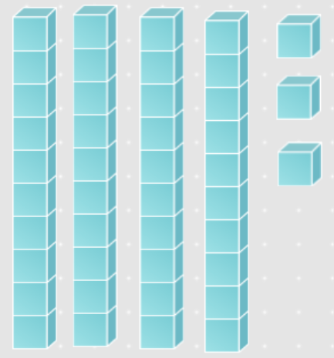
- Now start with the ones. On top you have 3, which means you need to solve 3 minus 7. Do you have enough ones to take away 7?

… No, you don’t have enough ones, so you need to regroup. This means take a ten and break it into ones.

Like this:
Before | After
 ➡️ | 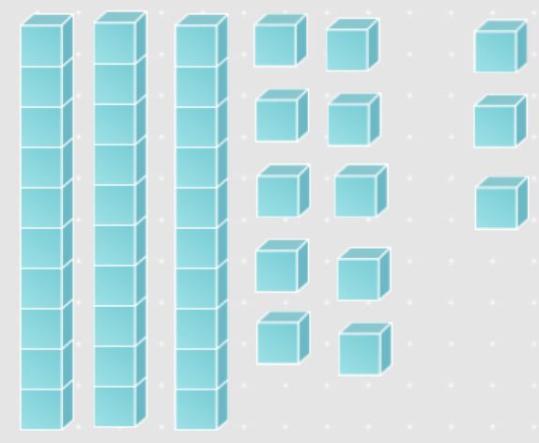

  - Now, how many ones do you have in all?
13 so the number 3 become in 13, because now you have 13 ones
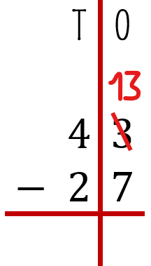
And because we take one ten and break it into ones, now we have only three tens. So the 4 tens becomes a 3 tens:
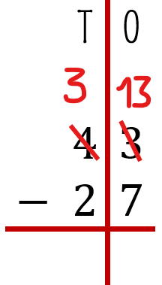
  - Now you have enough ones to take away 7, do it:
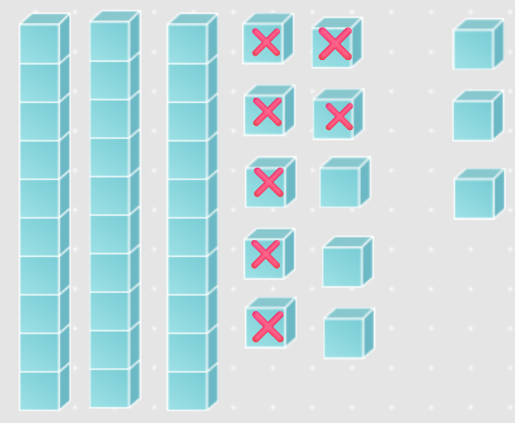

So… 13 – 7 = 6 | 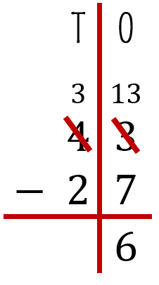
- Continue with tens. On top you have 3, which means you need to solve 3 minus 2. Do you have enough tens to take away 2?
Yes! Look:  👁️ 👁️ | 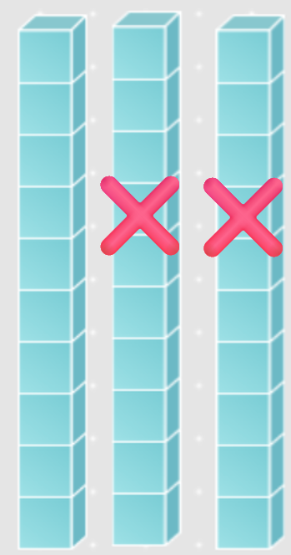
So… 3 – 2 = 1 | 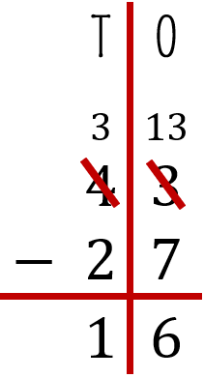

- Finally, the answer is 16:

 | ➡️ | 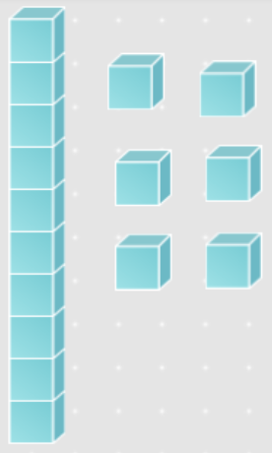

Exercise 4
 | T | O
 | $$5$$ | $$2$$
$$-$$ | $$2$$ | $$9$$
- Represent the number. Remember, you only need to represent the number on the top because you are going to subtract.
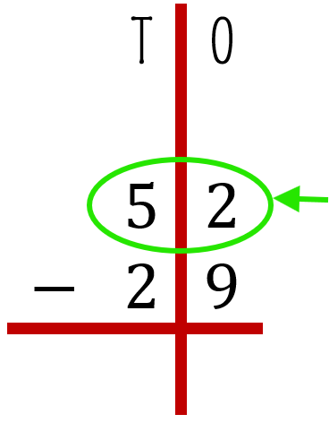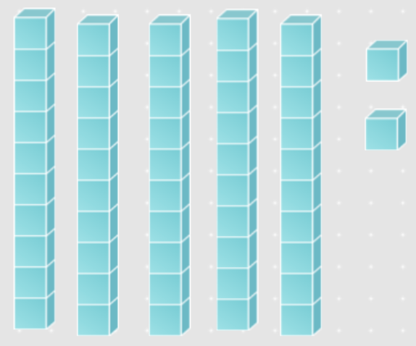
- Now start with the ones. On top you have 2, which means you need to solve 2 minus 9. Do you have enough ones to take away 9?

… No, you don’t have enough ones, so you need to regroup. This means take a ten and break it into ones.

Like this:
Before | After
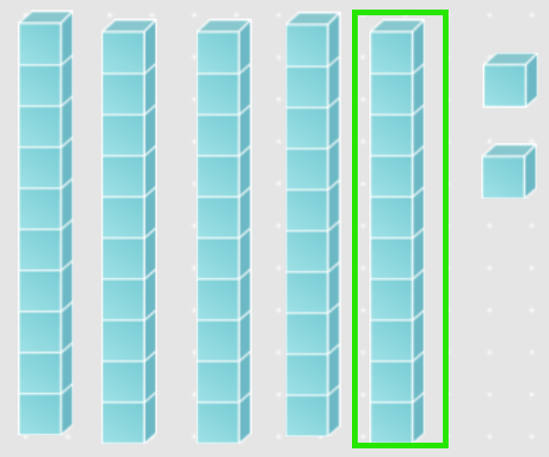 ➡️ | 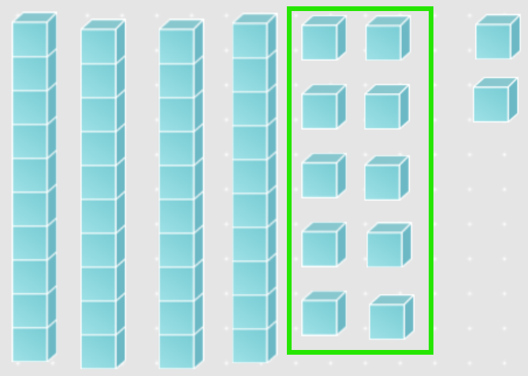

  - Now, how many ones do you have in all?
12 so the number 2 become in 12, because now you have 12 ones

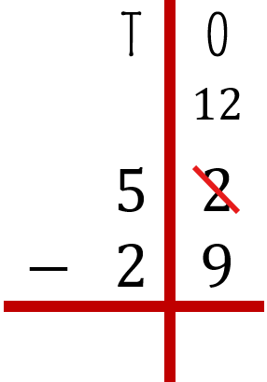
And because we take one ten and break it into ones, now we have only four tens. So the 5 tens becomes 4 tens:
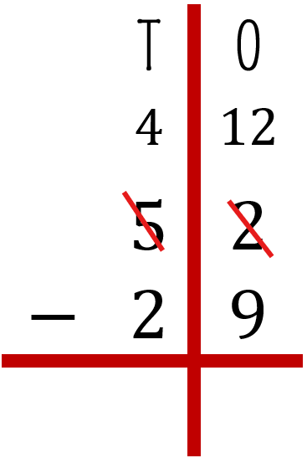
  - Now you have enough ones to take away 9, do it:
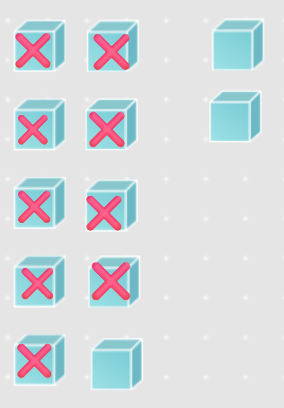
So… 12 – 9 = 3 | 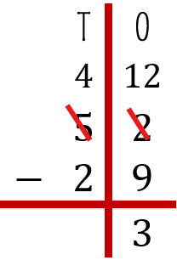
- Continue with tens. On top you have 4, which means you need to solve 4 minus 2. Do you have enough tens to take away 2?
Yes! Look:  👁️ 👁️ | 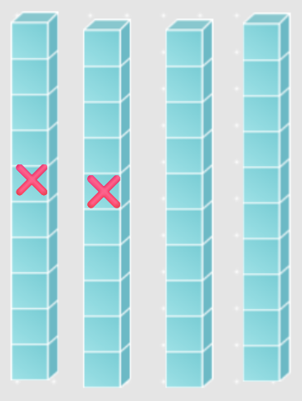
So… 4 – 2 = 2 | 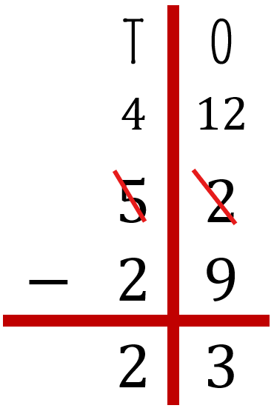

- Finally, the answer is 23:

 | ➡️ | 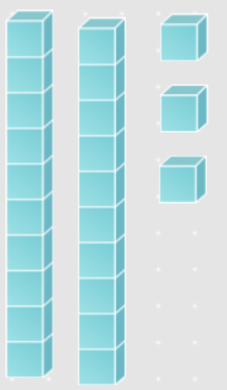

Manipulative tool:
Base ten blocks
https://www.coolmath4kids.com/manipulatives/base-ten-blocks
